2022

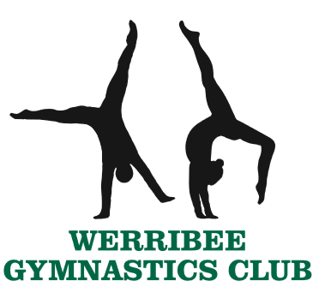
GYMSTAR HANDBOOK 2022

Contact information
Phone: (03) 9742 5446
Address: 52 Riverside Avenue, Werribee, VIC 3030
Website: www.werribeegymnastics.com.au
Facebook page: ‘Werribee Gymnastics Club’
Instagram: werribeegymnasticsclub

Club Administrator – Cathie
Enrolment, payment, invoicing & accounts, uniform (includes placing orders), timetable, missing training sessions/holidays, competition entry and payment.

info@werribeegymnastics.com.au

Gymstar Coordinator – Mel
Competition information, feedback/concerns/questions about the programme, holiday training bookings, event bookings.

gymstar@werribeegymnastics.com.au

Class Coach/es
For specific feedback/concerns/questions about gymnasts’ skills/progress/performance during classes and competitions, please speak to Cathie in the office to organise a time to chat with the specific coach.
Please do NOT contact coaches on their personal emails or interrupt them while they are coaching.

About Gymstar

The Gymstar programme is a recreational programme which allows gymnasts to participate in competitions that are structured to be enjoyable, positive and supportive. The Gymstar programme is designed to be inclusive of both the traditional men’s and women’s apparatus, making it available to all. Gymstar is perfect for gymnasts who train limited hours or prefer a less competitive environment. The main aim of the Gymstar programme is for all participants to enjoy the experience of participating to their full potential.

The Gymstar programme allows gymnasts to develop their gymnastics skills, confidence, understanding and passion for gymnastics in a relaxed, fun and friendly environment with a strong focus on teamwork and positive attitudes. Competitions within the Gymstar programme are optional. Gymnasts and families have the flexibility to choose which competitions, if any, the enter throughout the year.

This programme aims to build self-confidence and resilience in our gymnasts through challenging them during training and through experiences such as competitions. As a Club we aim to encourage not only skill development but also personal development by fostering a supportive and positive team environment.

Gymstar Levels & Events
Gymstar Levels
Gymstar is a Victorian programme originally developed by Donna Bronstein and Ross Bouskill and further developed by Tammy Robinson. It is currently solely owned and run by Gymnastics Victoria. The emphasis in Gymstar is on the execution of skills and routines rather than difficulty, scores and results.
The programme has been designed to be used in clubs as a complete programme for all genders and abilities. Gymstar is designed to allow gymnasts to move across to the Australian Levels Programme at level 6 or 7 after completing Gymstar 10 or remain within the Gymstar programme with the option to continue competing at Gymstar 10 or move into the Open section. The Gymstar programme is not intended for developmental squad gymnasts.

Gymstar Events
Gymstar Neutrons Gymstar Neutrons events are for gymnasts in Gymstar 1, 2 and 3. Participation is the focus of Neutrons and all gymnasts will receive a medal. Routines in these levels are judged out of 15.
Gymstar 1 presentations Gymnasts will receive a participation medal and a certificate with a banded star for each apparatus:
Gold star = 14.0 and above
Silver star = 13.5 – 13.9
Blue star = 12.9 – 13.4
Red star = 12.0 – 12.8
Green star = 10.5 – 11.9
Black star = 10.4 and below
Gymstar 2 presentations Gymnasts will receive an individual medal based on their overall score (calculated from their top 5 apparatus scores).
Gold medal = 69.0 and above
Silver medal = 66.3 – 68.9
Bronze medal with a blue ribbon = 62.7 – 66.2
Bronze medal with a red ribbon = 57.0 – 62.6
Bronze medal with a green ribbon = 51.5 – 56.9
Bronze medal with a black ribbon = 51.4 and below
Gymstar 3 presentations Gymnasts will receive an individual medal based on their overall score as per level 2 and a certificate listing all their scores. At Gymstar 3, 1st – 6th teams will also be awarded.

Gymstar Halos Gymstar Halos events also have a strong emphasis on participation and caters for gymnasts in Gymstar levels 4 – 8. Gymstar Halos events are designed for gymnasts training limited hours and for gymnasts, coaches and clubs who prefer a less competitive event. Gymnasts are required to compete on a minimum of 5 apparatus (one of which must be beam or uneven bars). All routines that meet skill and composition requirements will be judged out of 15.0. Any routines that include star skills (a list of skills designed to extend gymnasts and can be included in a gymnast’s routine) will be awarded a star on the gymnast’s certificate. Host clubs nominate their own ‘Challenge Award’ to be presented, such as best team spirit or least amount of falls on beam.
Gymstar Halos presentations Gymnasts will receive a certificate listing all their scores. Medals will be awarded for 1st – 3rd and ribbons will be awarded for 4th – 6th on apparatus and individual overall. Teams will be awarded 1st – 3rd. The host club challenge award will be awarded at each session.

Gymstar Titans Gymstar Titans events are designed for gymnasts, coaches and clubs who prefer a more competitive event. Gymnasts are required to compete on a minimum of 5 apparatus (one of which must be beam or uneven bars). All routines that meet skill and composition requirements will be judged out of a start score of 14.0 with 0.5 awarded per star skill paid. At Gymstar 4 – 8 a maximum of 2 star skills can be paid for a maximum start score of 15.0. At Gymstar 9 a maximum of 3 star skills can be paid for a maximum start score of 15.5. At Gymstar 10 a maximum of 4 star skills can be paid for a maximum start score of 16.
Gymstar Titans presentations Gymnasts will receive a certificate listing all their scores. Medals will be awarded for 1st – 3rd and ribbons will be awarded for 4th – 6th on apparatus and individual overall. Teams will be awarded 1st – 3rd.

Gymstar Open Gymstar Open events are recreational events for gymnasts who are turning 17 or older in the year of competition. Gymnasts over 17 may still enter regular Gymstar events if they want to participate in a more structured environment. Gymstar Open events have an emphasis on participation and rely heavily on the honesty of participants. The aim of these events is to give older gymnasts more opportunities to enjoy competing in a fun, relaxed, recreational environment. Gymnasts are required to compete on a minimum of 5 apparatus (one of which must be beam or uneven bars). Depending on the amount of event and division entries, age categories may be implemented.
Gymstar Open Halos Gymnasts can nominate a different level for each apparatus they chose to compete on. Gymnasts will be judged at their nominated level according to the rules outlined for Gymstar Halos events. All Gymstar Open Halos compete against each other regardless of level. Teams must be made up of gymnasts who are competing in the same division.
Gymstar Open Titans Gymnasts nominate one Gymstar level at the start of the event and compete at that level for all apparatus during that event. Gymnasts will be judged according to the rules outlined for Gymstar Titans events. All Gymstar Open Titans compete against each other regardless of level. Teams must be made up of gymnasts who are competing in the same division.
Gymstar Open presentations (Open Halos and Open Titans) Gymnasts will receive a certificate listing all their scores. Medals will be awarded for 1st – 3rd and ribbons will be awarded for 4th – 6th on apparatus and individual overall. Teams will be awarded 1st – 3rd. Challenge awards may be awarded at each session by judges.

Training requirements
Werribee Gymnastics Club asks gymnasts planning to compete in Gymstar competitions to commit to the following training hours.

- Gymstar 1 – 1.5 hour session once a week
- Gymstar 2 – 1.5 hour session once a week
- Gymstar 3 – 2 hour session once a week
- Gymstar 4 – 1-2 x 2 hour sessions per week
- Gymstar 5 – 2 x 2 hour sessions per week
- Gymstar 6 – 2 x 2 hour sessions per week

- Regular attendance and commitment to training is strongly recommended, especially if gymnasts are planning to enter competitions. Missing training sessions can have a large impact on a gymnast’s skill development and may cause them to fall behind.
- Gymnasts are asked to arrive 5-10 minutes early to every session, so they are ready to begin warm up as soon as their coach calls them to the floor.
*Gymnasts are NOT to enter the floor area outside of their training times and are NOT to play with or on equipment.*
- Gymnasts are expected to come with a positive attitude and willingness to learn and try their best.
- Please inform you child’s coach before training if they have an injury or anything else that may impact on their training session so that modifications can be made where necessary.
- Drink bottles MUST be brought to every session. Only water is permitted.

- Holiday training will be available for Gymstar level 4 and above gymnasts. Holiday training is not compulsory for Gymstar gymnasts but is highly recommended. Holiday training will generally be offered in the second week of the school holidays. Dates and times will be organised in advance. External training venues may also be organised.

Uniform requirements
Please see the office for sizing, ordering & purchasing the following items:
Item | Description | Details | Price | ORDERS DUE BY:
Sylvia P  Sleeveless Green Leotard | 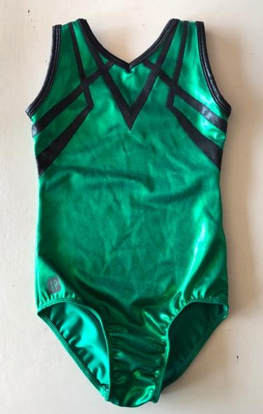 | Training leotard Gymstar 1 – 10  Optional competition leotard Gymstar 1 – 5  Competition leotard option Gymstar 6 – 10 | $75 | Friday 18th March 2022
Sylvia P Long Sleeve Green Leotard | 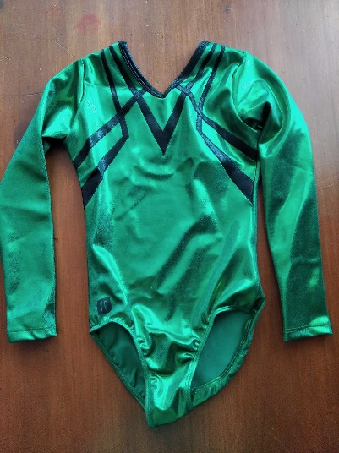 | Training leotard Gymstar 1 – 10  Optional competition leotard Gymstar 1 – 5  Competition leotard option Gymstar 6 – 10 | $95 | Friday 18th March 2022
Sylvia P ¾ Sleeve Black Leotard | 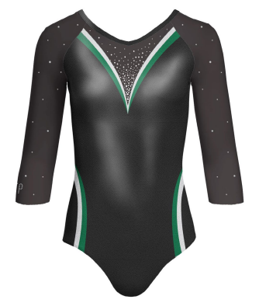  *Gymnasts will need to wear CLEAR straps and high cut black/nude underwear under their leotards if necessary* | Competition leotard:  GS 6 – 10  *ONLY to be worn at competitions*  Please follow the washing instructions on the tag. Do not wash these leotards too many times a year. Sometimes airing them out after a competition is enough. Do not hang them up using pegs or leave them outside in the sun. It is advised that you hang leotards on a coat hanger when storing them to avoid creasing and wrinkling. | $175 | Friday 18th March 2022
Club Tracksuit (Jacket Only) | 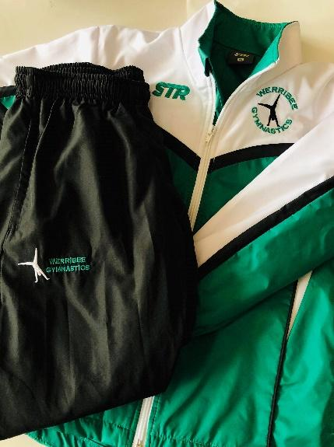 | Club tracksuit jacket:  Optional for Gymstar 1 – 5 competitions.  Compulsory for Gymstar 6 – 10 competitions.  Can be worn to and from training.  *MUST be clearly named.* | Jacket $61 | Friday 18th March 2022
NEW Club Leggings | TBC | Optional for Gymstar 1 – 5  Compulsory for Gymstar 6 – 10 (from 2023)  Can be worn at training and competitions | $75 | Friday 18th March 2022
Small  Green  Drawstring Bag | 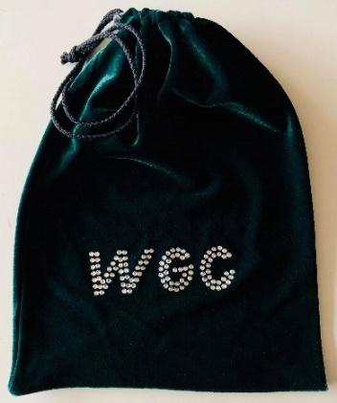 | Optional gym/grip bag | $25 | Purchase any time
Reisport Grips | 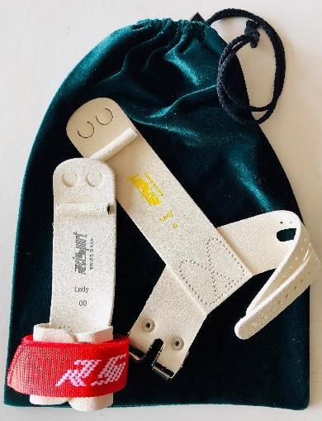 | Recommended for gymnasts Gymstar 5 and above  Available with Velcro straps (recommended for younger gymnasts) & buckles (recommended for older gymnasts).  *Long plain white wristbands will need to be purchased to wear under these (e.g. at Rebel Sport, etc.)* A small drawstring grip bag (Club or other) is also recommended to keep the grips & wristbands in. | $75 | Coaches will organise when needed
Sylvia P  Green  Crop Top |  | Optional training crop top  Gymstar 1 – 10  *Do NOT wear to competitions* | $45 | Purchase any time
Sylvia P  “WGC”  Shorts |  | Optional training shorts  Gymstar 1 – 10  Competition option  Gymstar 1 – 10 | $35 | Purchase any time
Green Scrunchie |  | Optional training and competition scrunchie | $7 | Purchase any time
Black Backpack | 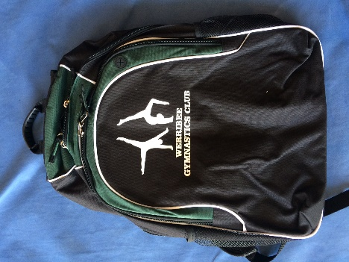 | Optional training and competition backpack | $40 | Purchase any time

Grips
As gymnasts move up the levels and begin to train more hours, they will spend more time during the week on bars. Therefore, it is recommended that all gymnasts in Gymstar 5 and above purchase grips to wear during training and competitions. This is to protect the gymnast’s hands, and to help them maintain grip on the bar for longer.
When gymnasts first begin using grips it can take a while to get used to them. Gymnasts may complain they have sore hands/wrists, or that they don’t like wearing grips at all, but this is completely normal as the body and mind adjust. Gymnasts will be taught the correct way to break in, prepare and wear their grips during class.
Gymnasts will need to keep their grips and wristbands in a small grip bag at training. Gymnasts may need to take their grips home on the last training session before a competition and bring them to the competition themselves. If gymnasts are required to take their grips home for competition, please do not forget to bring them back to training after the competition.

Training Attire
- Gymnasts in Gymstar 1 – 2 need to be dressed appropriately to allow freedom of movement and prevent injury or damage to equipment (no clothing with skirts, buttons, buckles, hoods or zips).
- Gymnasts dressed inappropriately will not be allowed to participate. Examples of appropriate clothing for gymnastics classes are - leotards, T-shirts, crop/singlet tops, leggings, shorts, tracksuit/yoga pants.
- Gymnasts in Gymstar 3 and above are required to wear a leotard or a crop top with tight shorts and/or leggings during training.
- Gymnasts in Gymstar level 6 – 10 will be expected to remove all loose clothing at the beginning of warm up in summer, and completion of warm up in winter.
- Gymnasts should wear supportive undergarments including crop tops and sports bras if necessary.
- A high level of personal hygiene is encouraged, including the use of deodorant.
- Hair must be neatly and securely tied up and off the face.
- No jewellery is to be worn during training, including fitness trackers – sleepers, studs and medic-alert bracelets are accepted.

TRAINING ‘gym bag’ recommendations: | - Water bottle  - Deodorant & spare sanitary items  - Rigid sports strapping tape  - Hair ties & bobby pins/clips  - Any rehab items needed (therabands, spikey ball, etc.)  - Any medication (must be labelled)

Competition Attire
- Gymnasts in Gymstar 1 – 3 are strongly encouraged to wear the green Club leotards and tight black shorts/leggings for competitions, however, this is not compulsory, and they can wear a plain black leotard or plain black fitted singlet and tight black shorts/leggings.
- Gymnasts in Gymstar 4 and 5 are required to wear the green Club leotard, either the sleeveless or long sleeve option, during competitions.
- Gymnasts in Gymstar 6 and above are required to wear a Club leotard during competition, this can be the green or black Club leotard.
- Gymnasts may compete in leotard and black leggings or black tight shorts.
- Gymnasts can NOT compete in crop tops or cropped singlets that show their midriff.
- Gymnasts in Gymstar 1 – 5 are strongly encouraged to wear the Club tracksuit jacket to competitions, however, this is not compulsory.
- Gymnasts in Gymstar 6 and above must wear the Club jacket with either the Club pants or plain black pants to competitions.
- Plain socks may be worn while waiting. Shoes are to remain with family in the spectator area.
- Hair must be neatly and securely tied up and off the face.
- No jewellery is to be worn during competition, including fitness trackers – sleepers, studs and medic-alert bracelets are accepted.
- A small snack may be brought to competition. Please be mindful of allergies (e.g. no nuts).

COMPETITION ‘gym bag’ recommendations: | All levels  - Water bottle  - Small snack (please not too many lollies, NO nuts)  - Any medication (must be labelled)  - Hair ties & bobby pins/clips  - Deodorant & spare sanitary items  Gymstar 5+  - Rigid sports strapping tape  - Grips & wrist bands
Competitions
Competitions within the Gymstar programme are optional. Gymnasts and families have the flexibility to choose which competitions, if any, they enter throughout the year.
The Gymstar competition season may begin towards the end of Term 2 and continue into the first few weeks of Term 4. A list of competitions will become available in the coming weeks.
Gymstar level 1 gymnasts are not required to memorise routines, therefore, coaches may prompt or talk them through their routines.
Every competition our gymnasts attend, our Club is required to provide judges. Without judges attending competitions, our gymnasts would not be able to compete. We strongly encourage anyone who is interested in getting involved in judging to contact us.

- A competition calendar will be distributed at the beginning of the year (once set by Gymnastics Victoria).
- Gymnasts can select the number of competitions (if any) they enter throughout the year
- Class coaches may specify specific competitions based on the readiness of the gymnast - please speak to your child’s coach before entering comps.
- A minimum number of entries is required for each level, if the minimum amount is not met, competition entry fees will be refunded.
- Competition entry fees vary for the different event types (Neutrons, Halos, Titans, Open) and will be advised at the beginning of each year
- Competitions must be paid for at the time of entering
- Competition locations vary and will be stated on the competition calendar
- Competition session start times and lengths vary depending on the number of competitors. Sessions may run up to approximately 2-3 hours.
- Session times are often not available until a week or two before the event, so please take this into consideration before entering.
- More comprehensive information regarding the times, date and locations of each competition, will be distributed as soon as the Gymstar coordinator is made aware of them.

Competition Format
Gymnasts may compete on all available apparatus; vault, uneven bars, beam, p-bars, rings and floor. Gymnasts must compete on a minimum of 5 apparatus (one of which must be beam or uneven bars) to be eligible for individual and team awards. Gymnasts start with a General Warm-Up of 15 minutes before lining up to be presented to the audience. All gymnasts will move to their first apparatus after presentation to the audience. Gymnasts will present themselves as a group to the judge before starting apparatus warm up.
Gymnasts will warm-up their skills on each apparatus before individually competing their routine for the judges. Once all gymnasts in a team have competed on the apparatus they may move with their coach to the next apparatus if it is free. There is no floor music for Gymstar levels 1, 2 & 3.
- Gymnasts cannot compete in both the Australian Levels Program and Gymstar in the same year.
- Once competition begins gymnasts are to remain with their coach at all times and are not to make contact with anyone in the audience, including parents.
- Gymnasts cannot to leave the competition floor without permission.
- Spectators are not permitted on the competition floor or to communicate with the competition floor manager, judges, coaches or gymnasts at any time.
- Flash photography is not permitted. Please make sure the flash on your camera/phone is turned off.
- A small cash fee will be asked upon spectator entry into the competition.
- Scores will not be displayed during the competition.

Teams
A team is made up of a minimum of 3 and a maximum of 5 gymnasts. Teams consist of gymnasts of any gender from the same Club.

Scoring
From a spectator’s perspective, a good routine is one where the skills flow smoothly in sequence, the gymnast seems confident (with chin lifted and shoulders back), maintains a tight body shape (including core, legs, feet, arms and fingers), performs skills with maximum height, power and flexibility, and sticks landings without wobbling or stepping.
By contrast, a poor routine is one where the skills look disjointed from one another, the gymnast seems hesitant and unsure, does not maintain a tight body shape (including chin down, shoulders hunched over, loose core, bent knees, flexed feet, bent arms and flopping fingers), displays a lack of height, power and flexibility in skills, and wobbles, steps or falls on landings.
- The score for each routine is made up of a D score (Difficulty) and an E score (Execution). The final score is calculated by adding the D score and the E score together. The D score relates to what skills the gymnast performs and the E score relates to how well the gymnasts performs those skills. If a gymnast misses a requirement/skill, it will be deducted from the D score. Deductions can be for various things including, but not limited to; falls, wobbles, bent legs, toes not pointed, legs apart, failure to hold skills for the required time, lack of height, lack of control, off direction, and steps on landings.
- All skills performed (with the exception of nominated Challenge skills in Halos events) count as elements toward routine requirements.
- All Gymstar 1-3 routines will have a D-Score of 5.0 with no bonus points awarded.
- At Gymstar 4-8 Halos events, routines have a base D-score of 5.0, with no bonus awarded for star skills. Any routines that include a paid star skill will be awarded a star to signify a ‘Star routine’.
- At Gymstar 4-10 Titans events, routines have a base D-Score of 4.0. Bonus of 0.5 is awarded for skills from the star skills list with the maximum bonus being 1.0 for Gymstar 4-8, a maximum of 1.5 for Gymstar 9 and a maximum of 2.0 for Gymstar 10. All attempted star skills will be awarded a bonus with deductions taken.
- At Gymstar 4-10 Titans if a star skill can be clearly recognised as a skill in the star skills list it will receive a bonus and deductions will be taken for any execution faults (which may be more than the 0.5 bonus awarded). If a star skill is performed following which the gymnast falls, it will still receive a bonus and deductions will be taken. A star skill performed with non-permitted spotting assistance will not receive a bonus. A skill will only count once as a star skill even if the skill is repeated.
- To determine individual all-around scores the gymnasts top 5 apparatus scores are added together.
- To determine team scores the top 15 apparatus scores are added together.

Competition feedback
Gymnasts will receive a ‘report card’ from coaches following each competition detailing their individual scores on each apparatus, as well as some written feedback. This will be done away from the competition venue. These details are NOT to be published on social media.
Photo Policy
During competitions and various training sessions, coaches may take photos/videos of gymnasts. These photos/videos will then be accessible only by the Club’s program coordinators and administration staff. Photos are immediately deleted from coaches’ devices once they have been passed onto our club device.
The Club may then use these photos/videos in marketing and promotional material such as on the Club’s Facebook and Instagram pages, posters, flyers handed out within the local community, etc. A gymnast’s first name may be used in certain circumstances, but no last names will be used.
Please contact the office ASAP if you would NOT like photos/videos of your child to be used in the public domain.
If you are taking photos/videos of your child at competitions or training, please try to get ONLY your child in the frame (e.g. no one else in the background). When taking photos/videos of other children (e.g. group photos), please ask for PERMISSION from parents/guardians to do so.

Getting involved!
If you would like to be more involved within the Club or Gymstar programme, and learn more about our sport, please contact info@werribeegymnastics.com.au. You can get involved by joining the committee, by acquiring your coaching and judging accreditation or by general volunteering.

Positive behaviour
We would like to remind everyone that Werribee Gymnastics Club has a zero tolerance policy on bullying and inappropriate behaviour. We expect that every participant, spectator, parent, guardian, coach and supporter show respect and kindness to one another. Our club highly encourages teamwork in an environment that is supportive of everyone’s efforts and achievements and we aim to help one another to reach their full potential.
Please remember to ‘treat others how you wish to be treated’. Our main aim is for gymnasts to enjoy coming to training and developing their gymnastics and personal skills.

If you have any further questions, please do not hesitate to contact us.

